**Big Data In Image Processing**

Table of Contents

1. Introduction 3

2. Big Data in Sports Image Processing and Video Analysis 3

2.1 Data Collection and Data Understanding 3

2.2 Example 1 – Cricket 5

2.3 Example 2 – Football 5

2.4 Example 3 – Basketball 5

3. Conclusion 6

4. Appendix: 6

# Introduction

The fast expansion of big data and advances in image processing and video analysis techniques have changed several sectors, including sports, in recent years. The role of big data in image processing and video analysis in sports such as cricket, football, and basketball are examined in this essay. It dives into the algorithms utilized for these assessments and offers a thorough explanation of how they are applied.

Sports teams and organizations are increasingly depending on data-driven insights to improve their performance and gain a competitive advantage in today's digital era. This change has been greatly aided by the use of big data and powerful algorithms in image processing and video analysis. This essay examines the use of big data in three major sports: cricket, football, and basketball.

# Big Data in Sports Image Processing and Video Analysis

## 2.1 Data Collection and Data Understanding

Before digging into the algorithms used for analysis, it is critical to comprehend the data-collecting and processing process in sports. During matches, advanced camera systems, sensors, and wearables collect vast amounts of data, such as video footage, player movements, ball trajectories, and physiological assessments. This data is then preprocessed and analyzed in conjunction with other contextual information.

If we take a single game across different sports, each might last anywhere from 1.5 hours to 8 hours. Each professional game is captured using more than 100 high-definition cameras, motion and trajectory detection sensors, and many more. The data comes in a very large volume and requires a lot of computational power to process it. The data in these matches are processed live during the matches and the best part is stored for further analysis of players and conditions. An example of live data feed analysis can be the ball tracking analysis for LBW in cricket or to check the offside call, in football. All the video and sensor data have id as timestamp and this is how the video is cropped and analyzed. Video is nothing but a set of images. Thus, we can apply the same algorithms that we apply for image processing and combine the results to produce a video analysis. Some of the references are as followed:

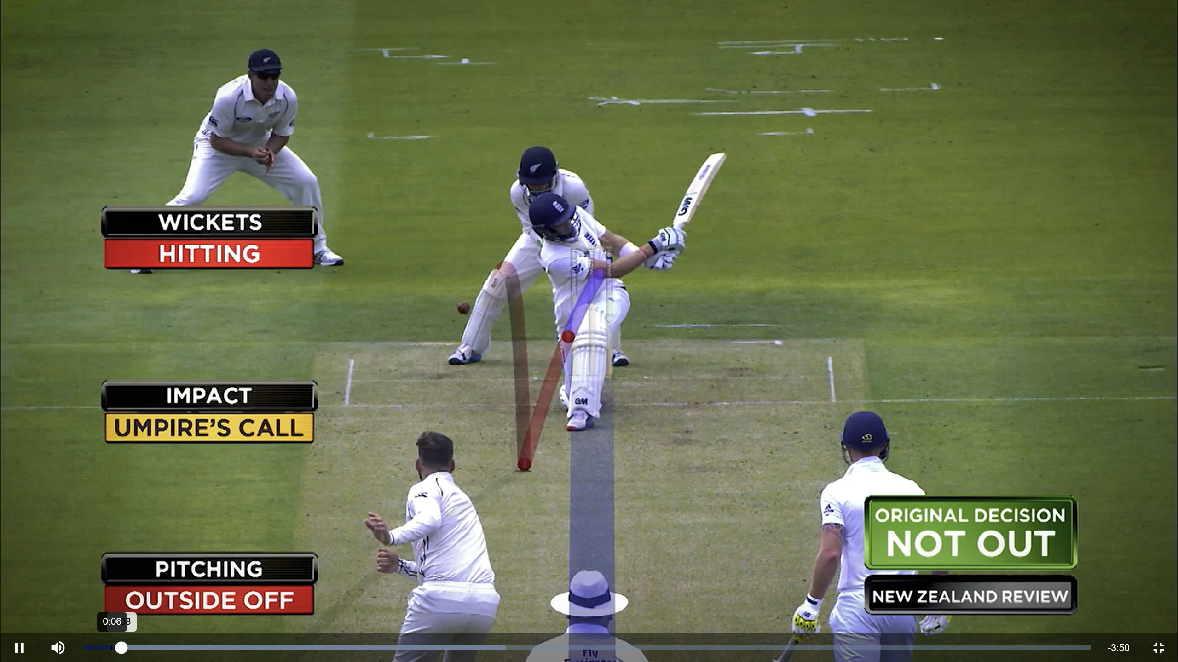

Image (1) – LBW check

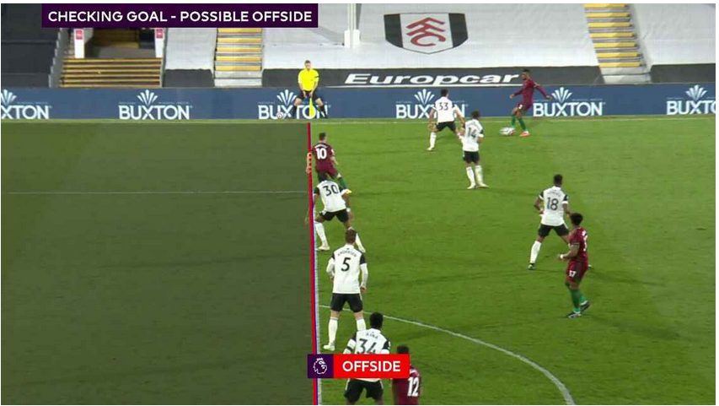

Image (2) – Offside check

## Example 1 – Cricket

Pitch tracking algorithms are an important part of cricket analysis. It uses computer vision methods to track the trajectory of the bowled ball. This system determines factors such as speed, swing, and spin by properly detecting the ball's path, offering significant insights into the game.

To follow the movement of players on the field, player tracking systems use computer vision and machine learning approaches. Individual players may be identified, their positions tracked, and their movements analyzed, allowing for extensive performance analysis, tactical appraisal, and player-specific insights.

## Example 2 – Football

In football analysis, object detection and tracking techniques are critical. They recognize and track players, the ball, and other on-field objects. For precise and real-time identification, techniques such as convolutional neural networks (CNNs) are often used, enabling applications such as player monitoring, ball possession analysis, and tactical analyses.

During a football match, action recognition algorithms scan video data to recognize and classify various events and actions. Deep learning models are used in these algorithms to detect activities like passes, shots, tackles, and goals. These techniques enable in-depth analysis of individual performance, team strategy, and match dynamics by giving accurate event timestamps.

## Example 3 – Basketball

Adding powerful shot analysis techniques, big data, and image processing has altered basketball analysis. These algorithms use computer vision techniques to recognize shot attempts, monitor the trajectory of the ball, and calculate shooting percentages from various places on the court. Such analytics inform teams on shot selection, shooting efficiency, and opponent defensive plans.

To evaluate basketball player performance, player performance evaluation algorithms integrate player tracking and event recognition techniques. These algorithms are capable of analyzing player movement, shot selection, passing accuracy, and defensive contributions. Teams may make educated judgments about player selection, replacement methods, and game strategy by gathering and analyzing individual player data.

# Conclusion

Sports such as cricket, football, and basketball have been transformed by the use of big data, image processing, and video analysis tools. Teams and organizations may acquire significant insights into player performance, tactical strategy, and game dynamics by utilizing advanced algorithms. Algorithms used in these sports include pitch tracking, player tracking, object detection, action recognition, shot analysis, and player performance evaluation. The potential for additional innovation in sports analysis utilizing big data and image processing techniques is enormous as technology advances, promising to transform the way sports are played, taught, and studied.

# Appendix:

Image 1: <https://www.icc-cricket.com/video/312199> (credit - ICC-cricket)

Image 2: <https://www.espn.co.uk/football/story/_/id/37619745/new-premier-league-2021-22> (Credit - ESPN-UK)